- A student has been asked to determine the volume V of a wire of length l. The wire has a circular cross-section of diameter d.

(a) Describe the procedure to be adopted in order to measure, as accurately as possible, the diameter of the wire.

………………………………………………………………………………………………

………………………………………………………………………………………………

………………………………………………………………………………………………

………………………………………………………………………………………………
[3]

(b) It was found that, for this wire,

diameter = (0.84 ± 0.04) mm
length = (946 ± 3) mm.

The volume V of the wire is given by

V =  πd²l

Calculate the percentage uncertainty in the measurement of

- the diameter d,

% uncertainty in d = ………………………

- the length l,

% uncertainty in l = ………………………..
- the volume V.

% uncertainty in V = ……………………….
[4]

- An archer fires an arrow with an initial speed v and hits a target which is a distance d away and on the same horizontal level as the bow, as illustrated in Figure 1.

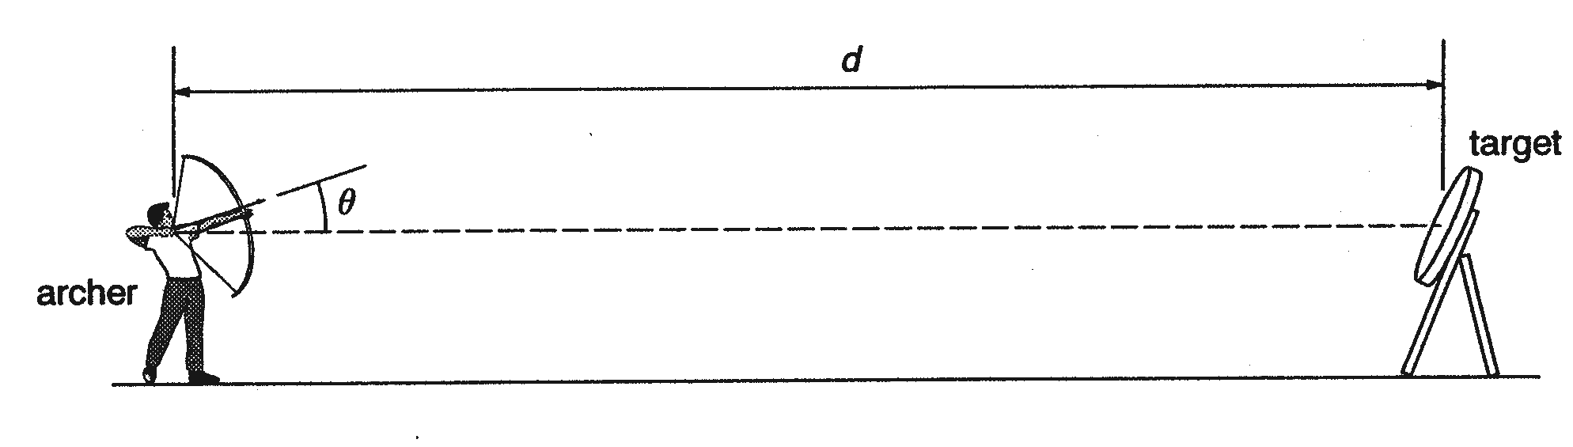
Figure 1

The arrow is aimed so that, on release, it makes an angle θ with the horizontal.

(a) Assuming air resistance to be negligible, write down an expression for

- d in terms of v, θ and the time of flight t,

……………………………………………………………………………………

- the time of flight t in terms of v, θ and the acceleration of free fall g.

……………………………………………………………………………………..
[3]

(b) The distance d is given by the expression

d = 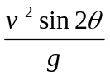.

Calculate the angle θ for an arrow with initial speed v = 32 ms⁻¹ and a target at a distance d of 94 m from the bow.

θ = ……………….. °
[2]
(c) State whether the angle θ would, in practice, be larger or smaller than that calculated in (b) for the arrow to hit the target.

………………………………………………………………………………………...
[1]

3. (a) What is an elastic collision?

.…………………………………………………………………………………………

………………………………………………………………………………………….
[1]
(b) A moving bullet hits a stationary target, and becomes embedded inside it. State whether the collision is elastic or inelastic, and state what energy changes, if any, occur.

….………………………………………………………………………………………
.…………………………………………………………………………………………

.…………………………………………………………………………………………

.…………………………………………………………………………………………

.…………………………………………………………………………………………
[3]

4. (a) State the conditions for a system to be in equilibrium.

.…………………………………………………………………………………………

.…………………………………………………………………………………………

.…………………………………………………………………………………………
[2]
(b) Currents in the sea water cause the buoy to be displaced so that the rope makes an angle of 35° with the vertical, as shown in Figure 4.1

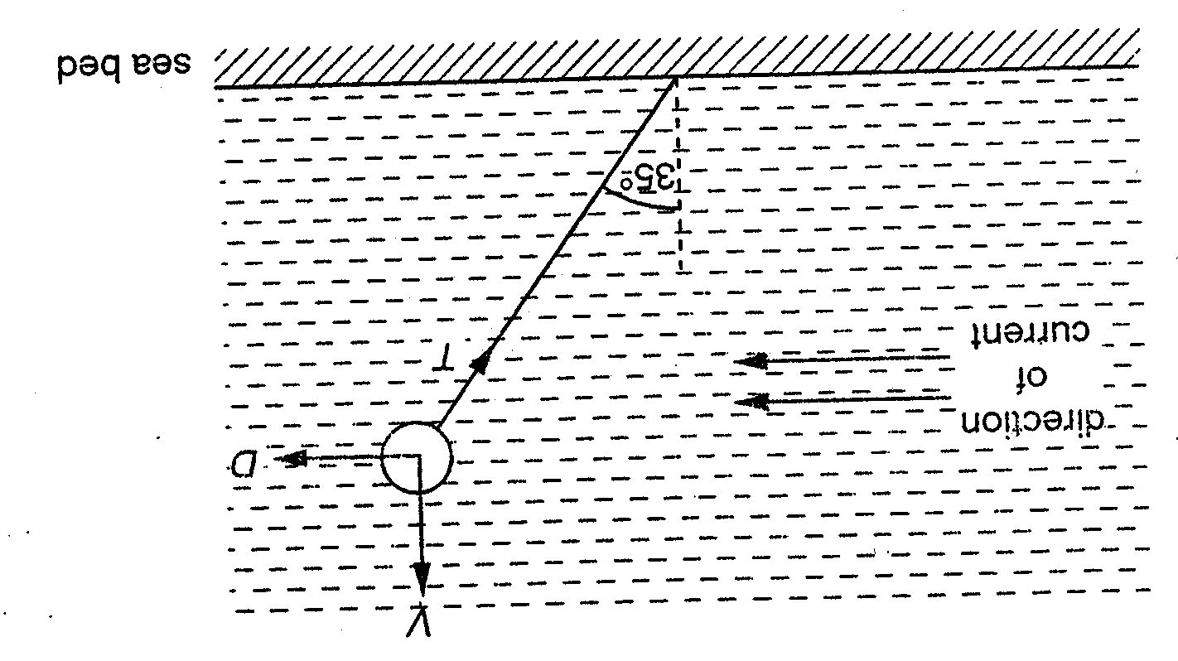
Figure 4.1

The buoy may be considered to be acted upon by three forces, the tension T in the rope, a horizontal force D and a vertical force V equal to 600 N.

- Using a scale of 1.0 cm to represent 100 N, complete Fig 4.2 to produce a vector triangle for the three forces acting on the buoy.
Line of action
of force D

Line of action of
force V

Fig 4.2

- Use your vector triangle to determine the magnitude of the force D.

D = ……………… N
[4]

5. (a) What is meant by the internal energy of a system?

….………………………………………………………………………………………

….………………………………………………………………………………………
[2]

(b) State, and explain whether the internal energy of the following increases, decreases or does not change.

- Solid gold is melting to its liquid form at the same temperature

….………………………………………………………………………………………

….………………………………………………………………………………………

….………………………………………………………………………………………
- Water, to which ice, has been added.

….………………………………………………………………………………………

….………………………………………………………………………………………

….………………………………………………………………………………………
[4]

6. The Young modulus for high density polythene is 30 MPa.

(a) A strip of polythene with a rectangular cross-section measuring 50 mm by 0.2 mm is stretched longitudinally by a force F.

- Calculate the value of F to produce a strain of 0.0005.

Force = ………………...… N

- If the original length of the strip is 80 cm, calculate the extension, x that would occur.

x = …………...…………. cm

- On Figure 6.1, sketch a force-extension graph up to the value of F and x calculated above (assuming that the polythene obeys Hooke’s law)
F

x

Figure 6.1
- Hence, calculate the work done in stretching the strip.

Work done = …………….. J
[6]

(b) The Young modulus for mild steel is 2 x 10⁵ MPa. On Figure 6.1, sketch the graph for an identically sized strip of mild steel.
[1]

7. (a) A student sets up the apparatus illustrated in Figure 7.1 in order to observe two-source interference fringes.

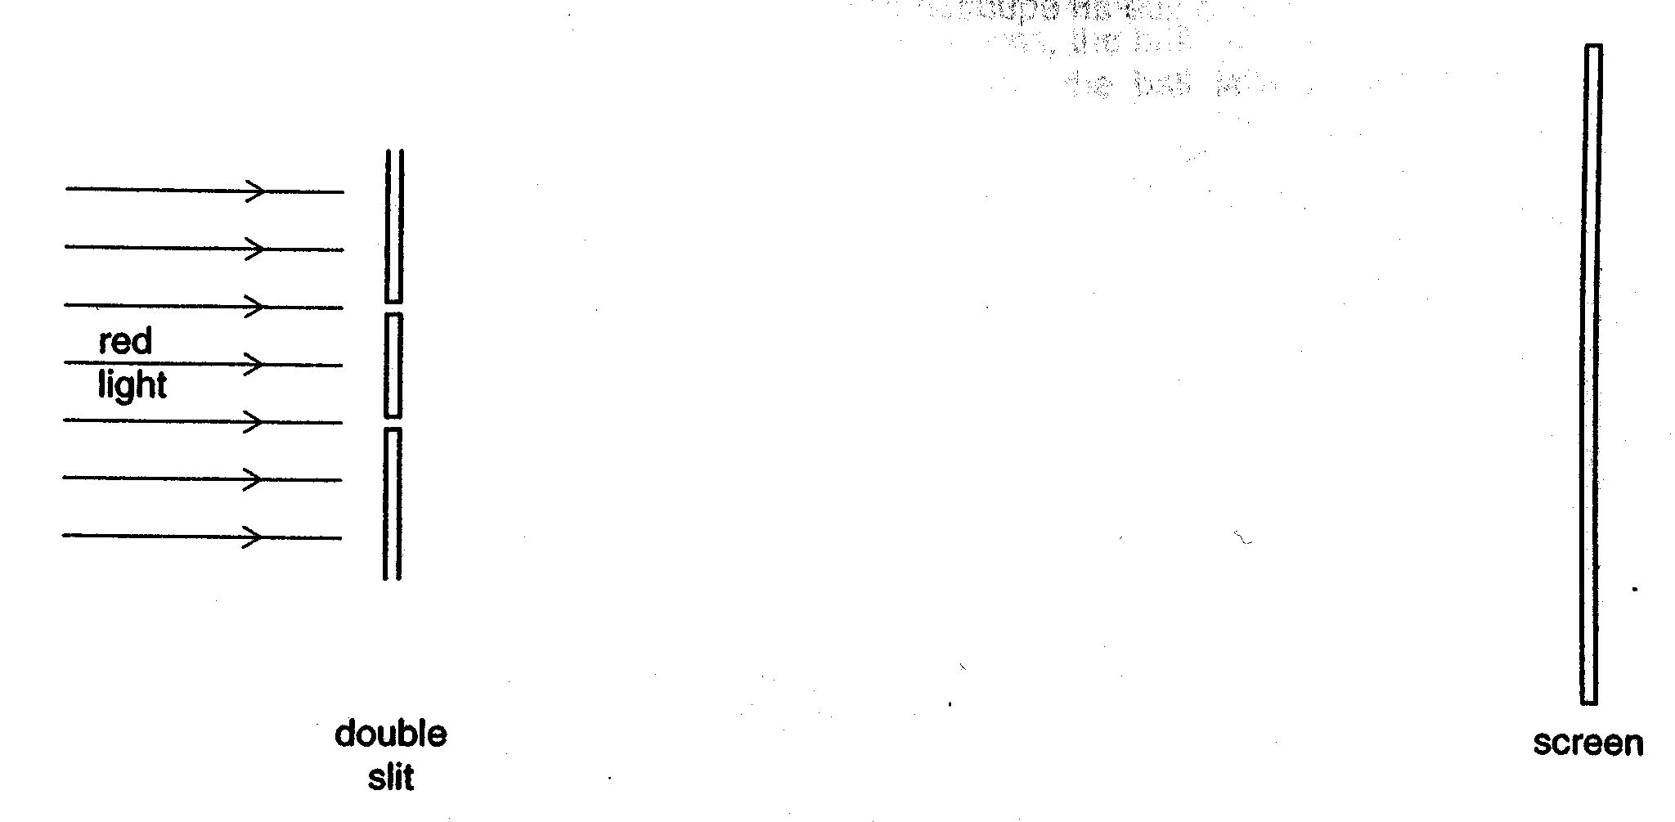
Figure 7.1 (not to scale)

- State a suitable separation for the two slits in the double slit.

…………………………………………………………………………………………
[1]

- State and explain what change, if any, occurs in the separation of the fringes and in the contrast between bright and dark fringes observed on the screen, when each of the following changes is made separately.

  - Increasing the intensity of the red light incident on the double slit

………………………………………………………………………………………

………………………………………………………………………………………

………………………………………………………………………………………

………………………………………………………………………………………
[3]

  - Increasing the distance between the double slit and the screen.

…...…………………………………………………………………………………

………………………………………………………………………………………

………………………………………………………………………………………

………………………………………………………………………………………
[4]
(b) A string is stretched between 2 fixed points. It is plucked, causing it to form a wave as illustrated in Figure 7.2.

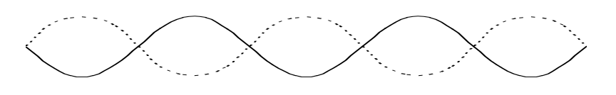
120 cm

Figure 7.2

Length of the string is 120 cm.

- Calculate the wavelength of the wave.

Wavelength =…………… m

- The frequency of the string is 120 Hz. Calculate the speed of the wave on the string.

Speed = ……………….. ms⁻¹
[4]

8. (a) Define electrical resistance of a conductor.

………………………………………………………………………………………………

………………………………………………………………………………………………
[1]

(b)
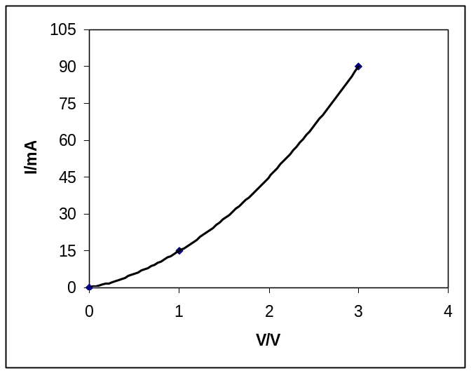
P
S
Figure 8.1
- Calculate the change in resistance between points P and S marked on the graph in Figure 8.1.

Change in resistance = ………………...… Ω
- Suggest an electrical device that may produce such current-voltage characteristics shown in Figure 8.1

………………………………………………………………………………………
[4]

(c) Figure 8.2 shows an electrical circuit in which the internal resistance of the battery is negligible.

4 V
A
B
4.0 Ω
2.0 Ω
Figure 8.2

Complete Figure 8.3. [3]

Circuit Component | A | B
Potential difference / V
Current / A
Power / W
Figure 8.3

9. One isotope of iron may be represented by the symbol 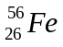. State, for one nucleus of this isotope,

- the number of protons : ………….…………

- the number of neutrons: …………………….

- the number of electrons: …………………….

- the mass: ……………………. kg
[4]

